[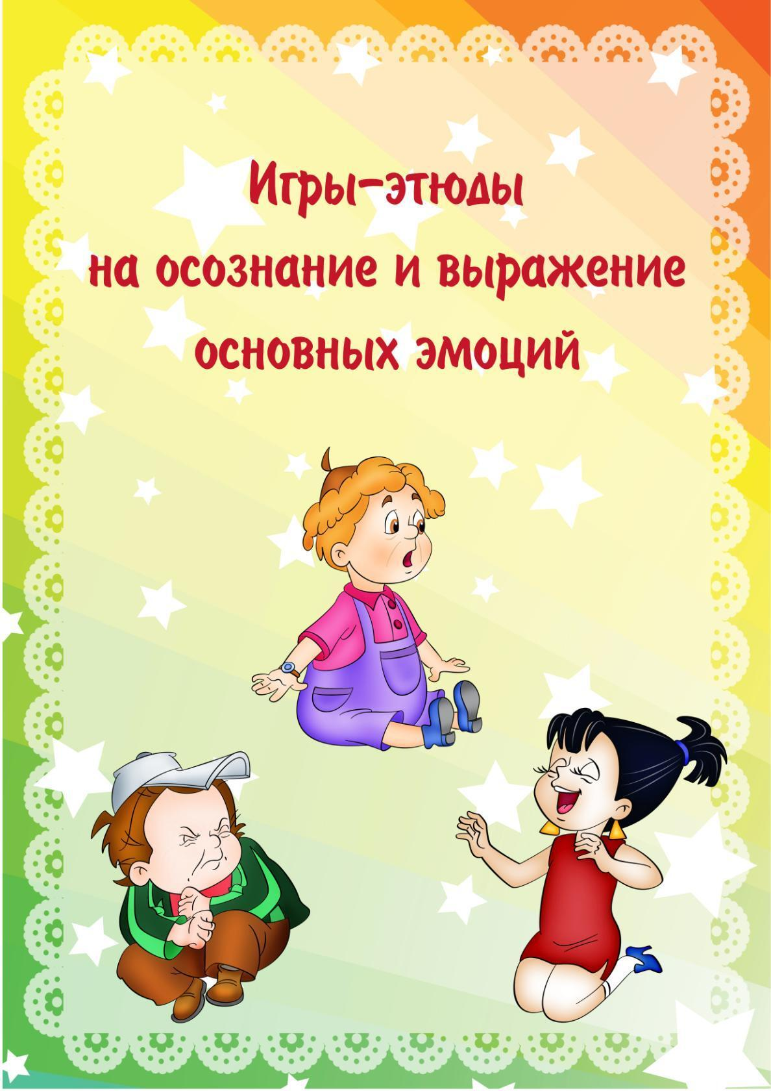](https://ok.ru/dk?cmd=PopLayerPhoto&st.layer.cmd=PopLayerPhotoOuter&st.layer.type=GROUP&st.layer.revNav=off&st.layer.limitedUi=false&st.layer.closeLayers=off&st.layer.sphotoIds=904700938197%3B904700937941%3B904700937685%3B904700937429%3B904700937173%3B904700936917%3B904700936661%3B904700936405%3B904700936149&st.layer.showNav=on&st.layer.photoAlbumId=52327617003733&st.layer.epm=off&st.layer.photoId=904700938197&st.layer.wasRedirect%2C=off&st.layer.opl=off&st.layer.navStartPhotoId=904700938197&st.layer.navStartAlbumId%2C=52327617003733&st.layer.sbd=off&st.cmd=altGroupMain&st.groupId=52327565361365&st.visitType=GROUP&st._aid=GroupTopicLayer_openPhotoLayer)

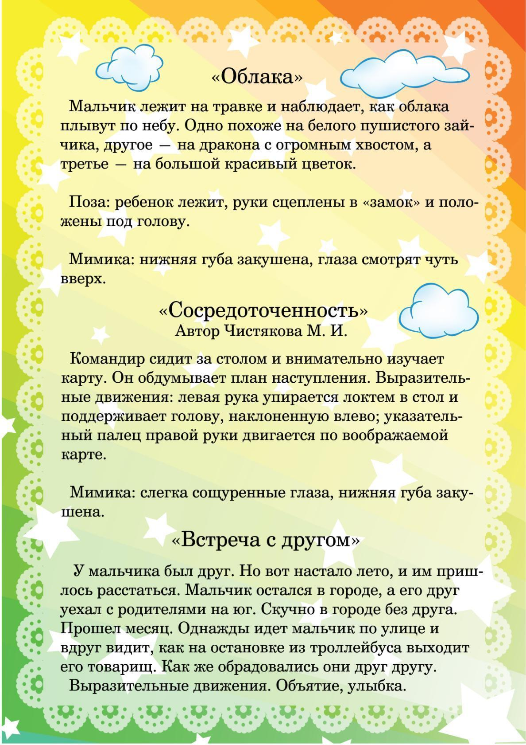

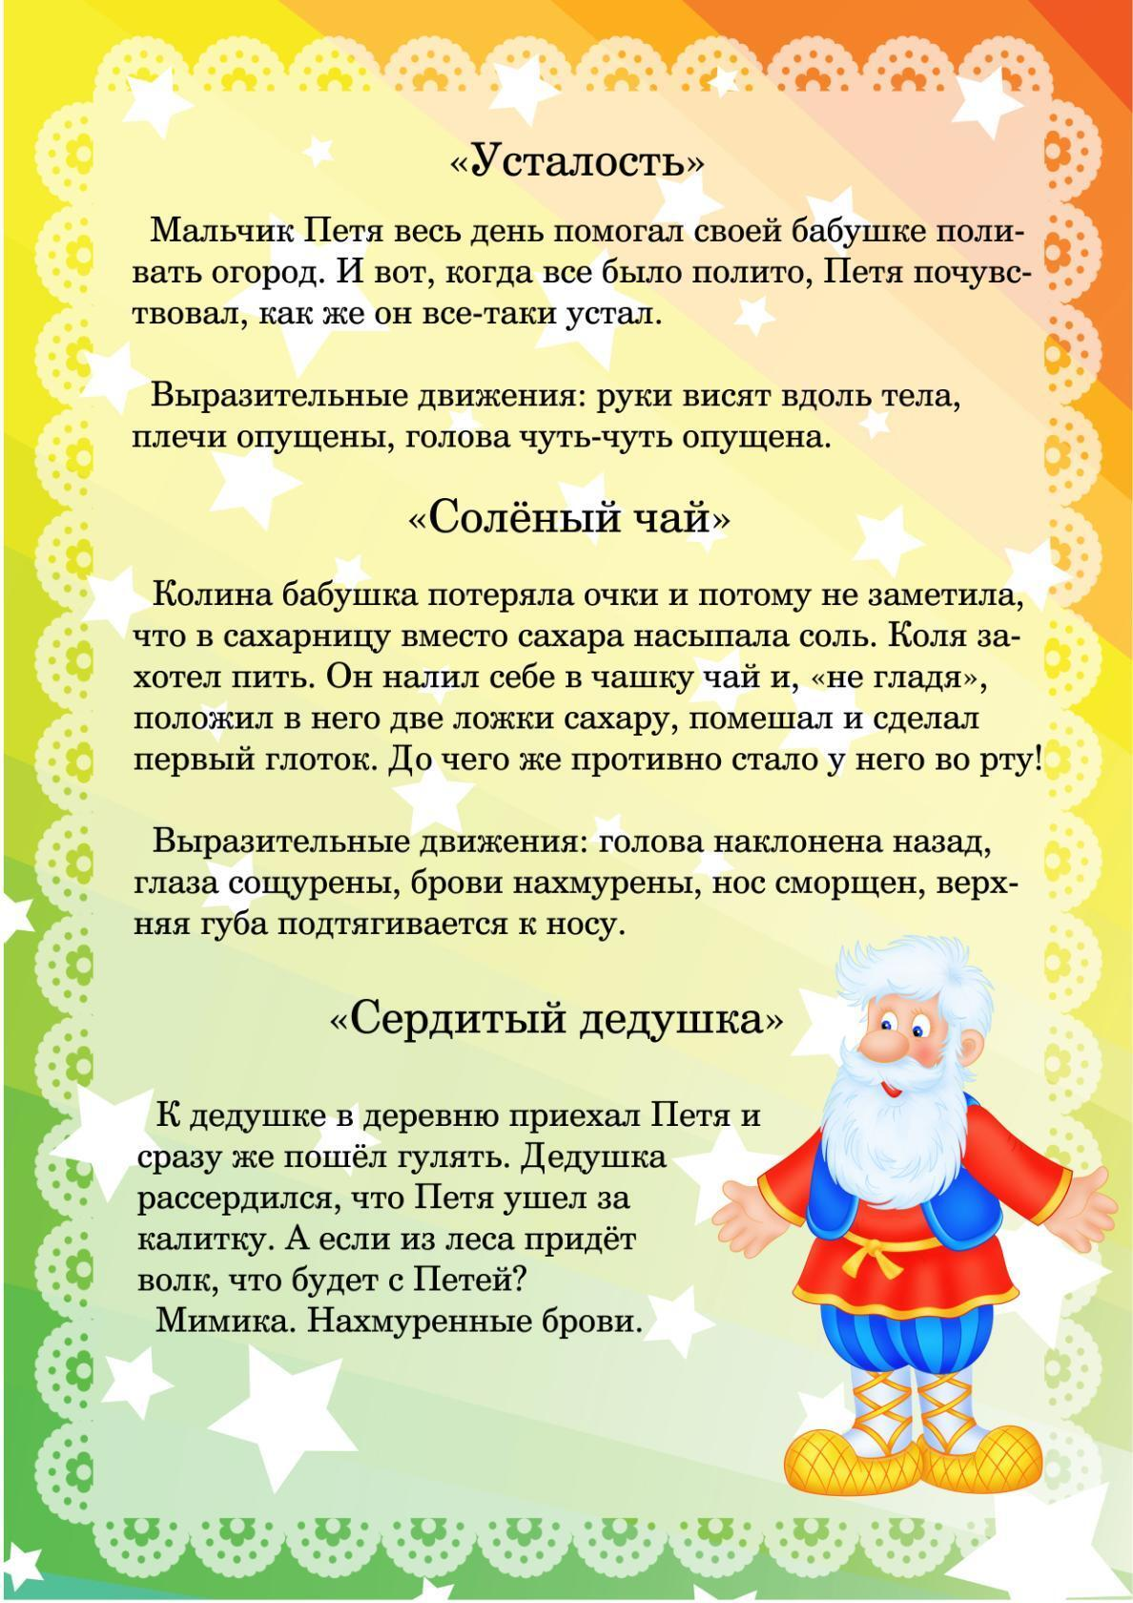

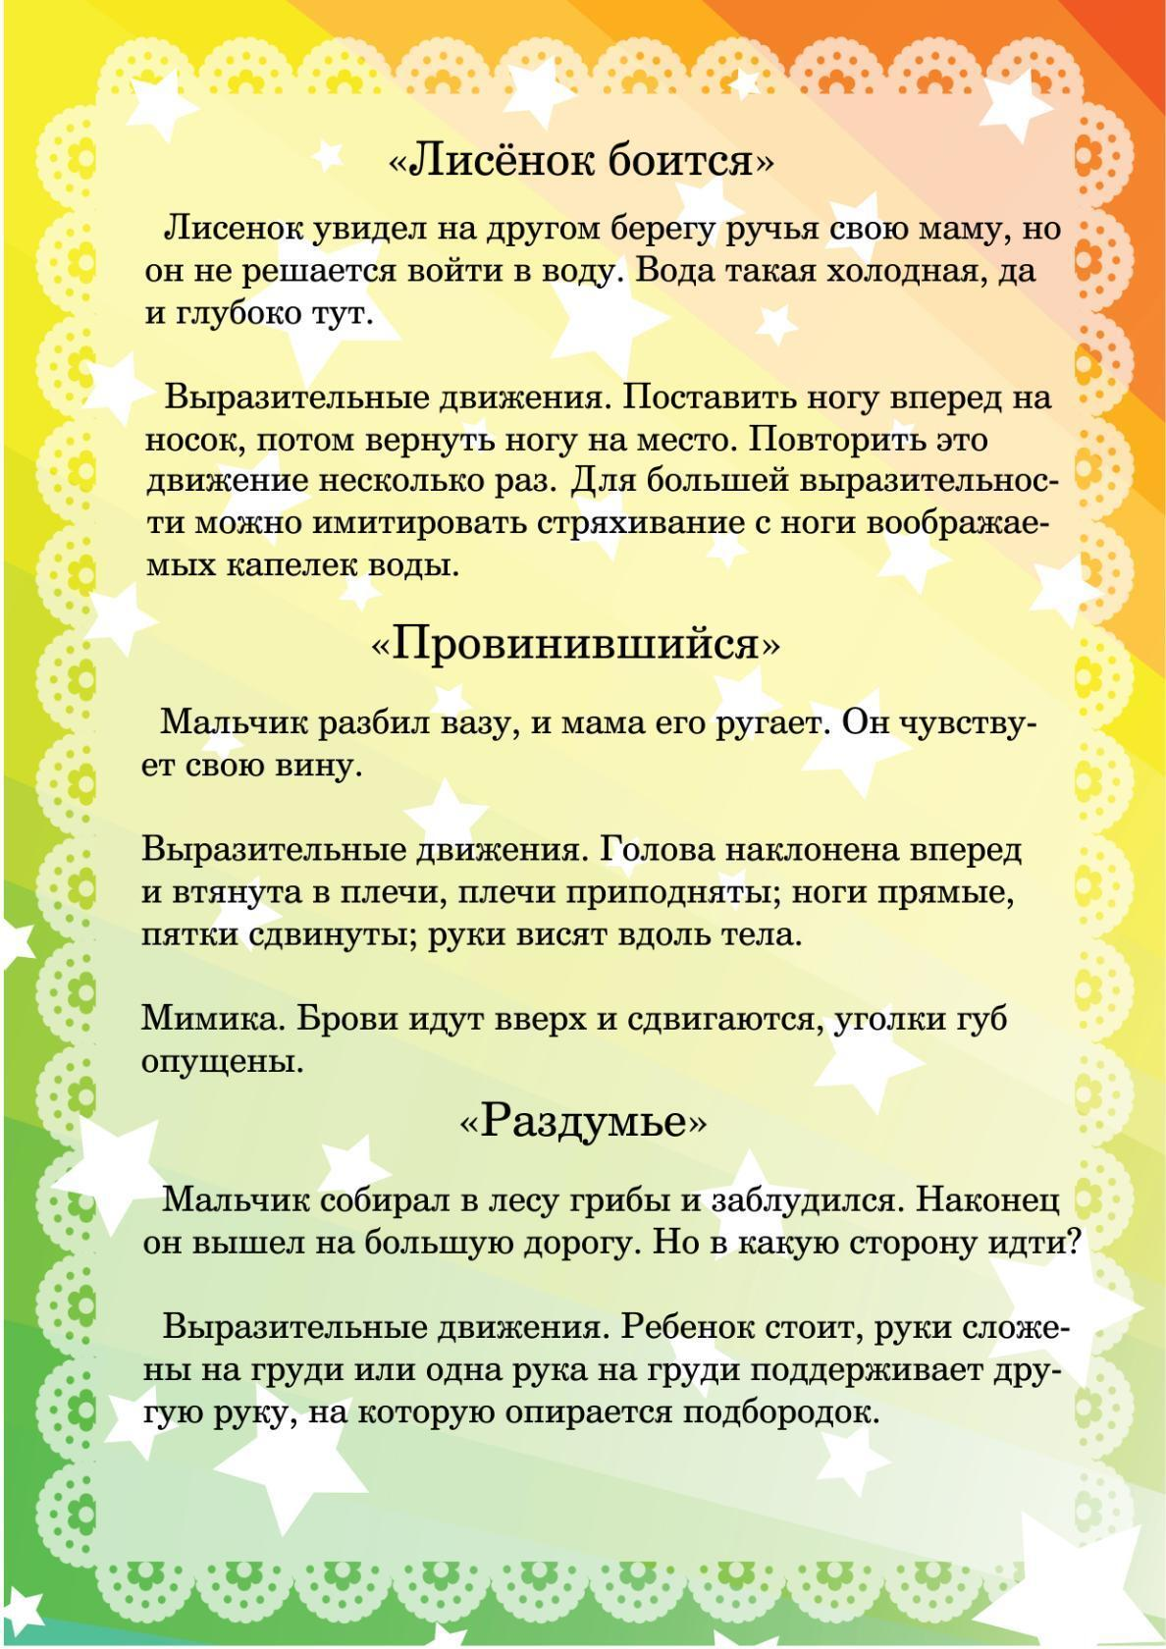



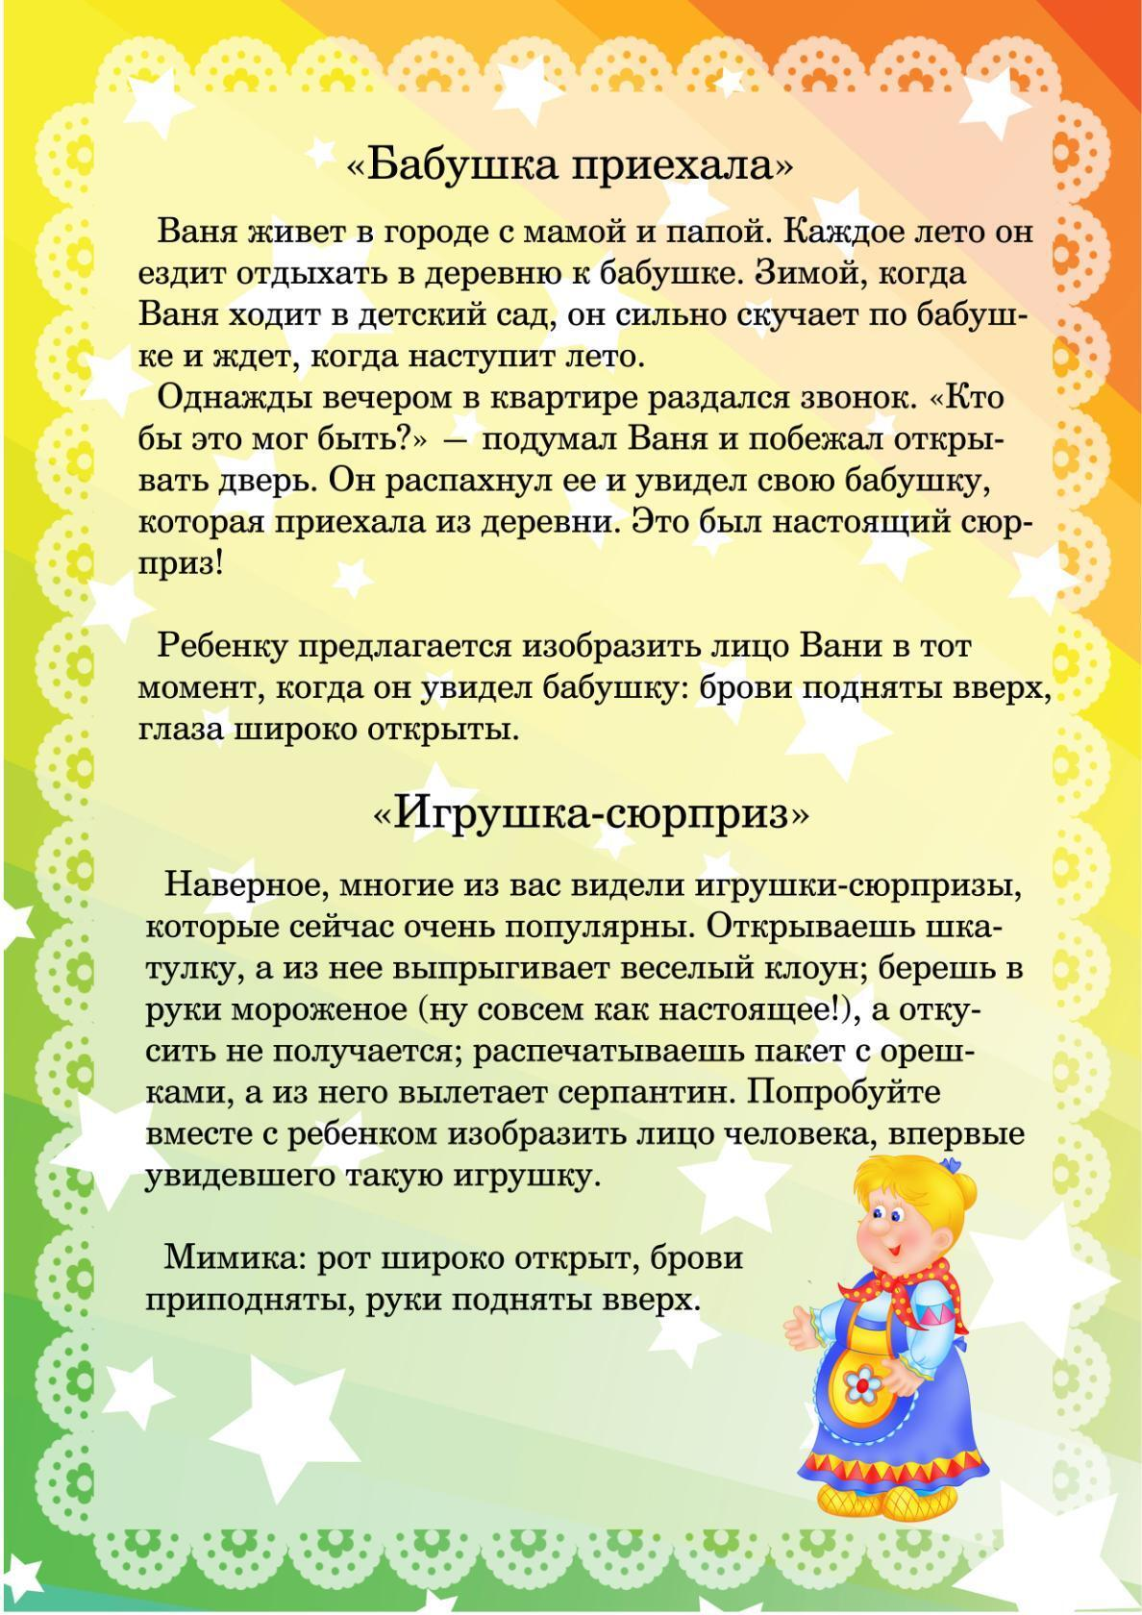











[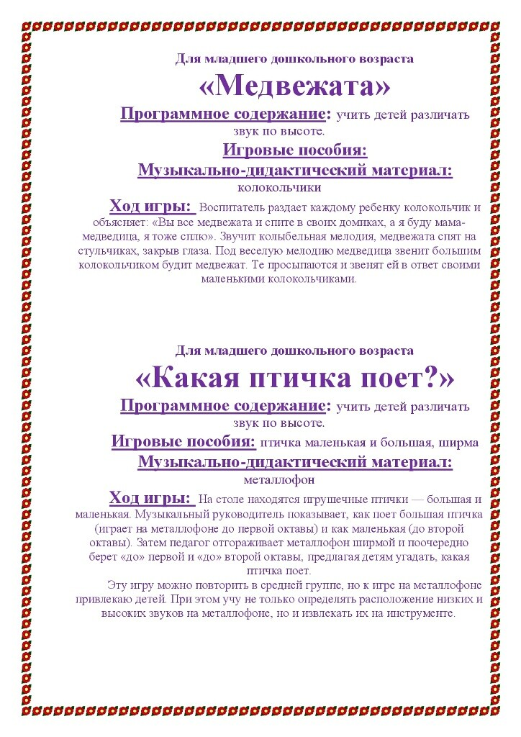](https://ok.ru/dk?cmd=PopLayerPhoto&st.layer.cmd=PopLayerPhotoOuter&st.layer.type=GROUP&st.layer.revNav=off&st.layer.limitedUi=false&st.layer.closeLayers=off&st.layer.sphotoIds=904606600917%3B904606600661%3B904606600405%3B904606600149%3B904606599893%3B904606599637%3B904606599381%3B904606599125%3B904606598869%3B904606598613%3B904606598357%3B904606598101%3B904606597845%3B904606597589%3B904606597333%3B904606597077%3B904606596821%3B904606596565%3B904606596309%3B904606596053%3B904606595797%3B904606595541%3B904606595285&st.layer.showNav=on&st.layer.photoAlbumId=52327617003733&st.layer.epm=off&st.layer.photoId=904606600917&st.layer.wasRedirect%2C=off&st.layer.opl=off&st.layer.navStartPhotoId=904606600917&st.layer.navStartAlbumId%2C=52327617003733&st.layer.sbd=off&st.cmd=altGroupForum&st.groupId=52327565361365&st._aid=GroupTopicLayer_openPhotoLayer)

[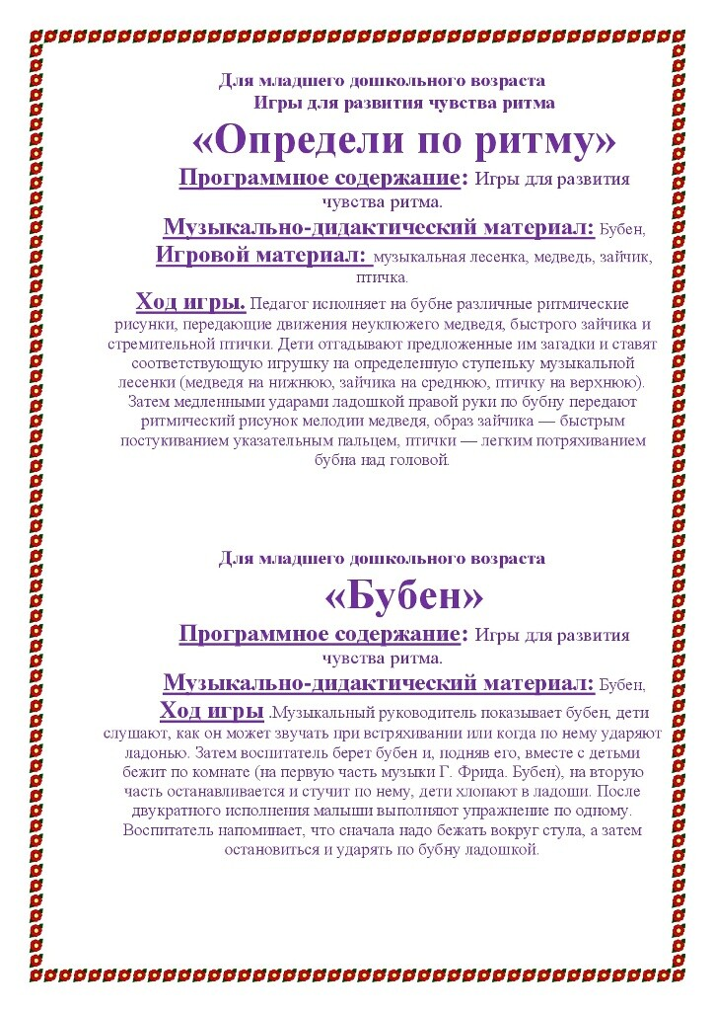](https://ok.ru/dk?cmd=PopLayerPhoto&st.layer.cmd=PopLayerPhotoOuter&st.layer.type=GROUP&st.layer.revNav=off&st.layer.limitedUi=false&st.layer.closeLayers=off&st.layer.sphotoIds=904606600917%3B904606600661%3B904606600405%3B904606600149%3B904606599893%3B904606599637%3B904606599381%3B904606599125%3B904606598869%3B904606598613%3B904606598357%3B904606598101%3B904606597845%3B904606597589%3B904606597333%3B904606597077%3B904606596821%3B904606596565%3B904606596309%3B904606596053%3B904606595797%3B904606595541%3B904606595285&st.layer.showNav=on&st.layer.photoAlbumId=52327617003733&st.layer.epm=off&st.layer.photoId=904606600405&st.layer.wasRedirect%2C=off&st.layer.opl=off&st.layer.navStartPhotoId=904606600405&st.layer.navStartAlbumId%2C=52327617003733&st.layer.sbd=off&st.cmd=altGroupForum&st.groupId=52327565361365&st._aid=GroupTopicLayer_openPhotoLayer)

[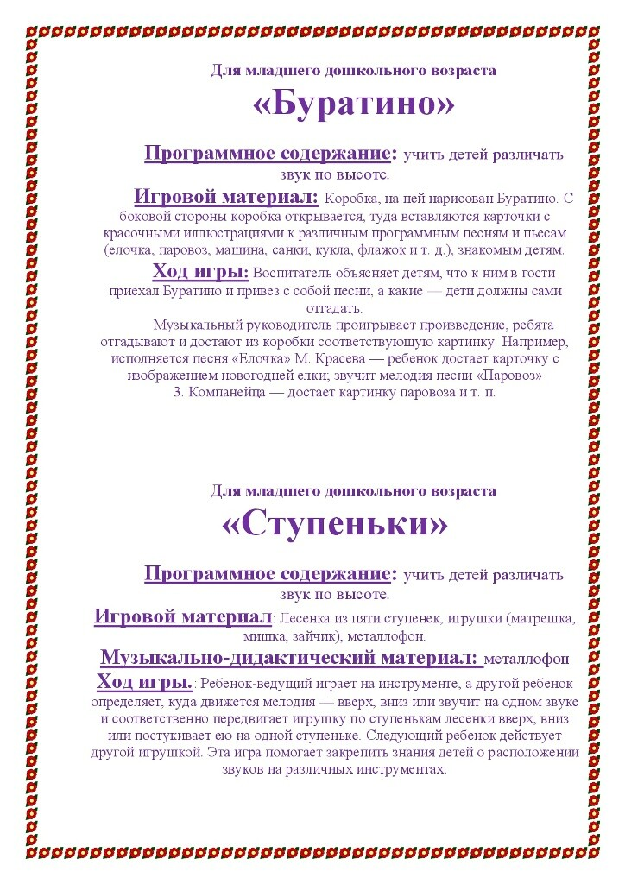](https://ok.ru/dk?cmd=PopLayerPhoto&st.layer.cmd=PopLayerPhotoOuter&st.layer.type=GROUP&st.layer.revNav=off&st.layer.limitedUi=false&st.layer.closeLayers=off&st.layer.sphotoIds=904606600917%3B904606600661%3B904606600405%3B904606600149%3B904606599893%3B904606599637%3B904606599381%3B904606599125%3B904606598869%3B904606598613%3B904606598357%3B904606598101%3B904606597845%3B904606597589%3B904606597333%3B904606597077%3B904606596821%3B904606596565%3B904606596309%3B904606596053%3B904606595797%3B904606595541%3B904606595285&st.layer.showNav=on&st.layer.photoAlbumId=52327617003733&st.layer.epm=off&st.layer.photoId=904606600661&st.layer.wasRedirect%2C=off&st.layer.opl=off&st.layer.navStartPhotoId=904606600661&st.layer.navStartAlbumId%2C=52327617003733&st.layer.sbd=off&st.cmd=altGroupForum&st.groupId=52327565361365&st._aid=GroupTopicLayer_openPhotoLayer)

[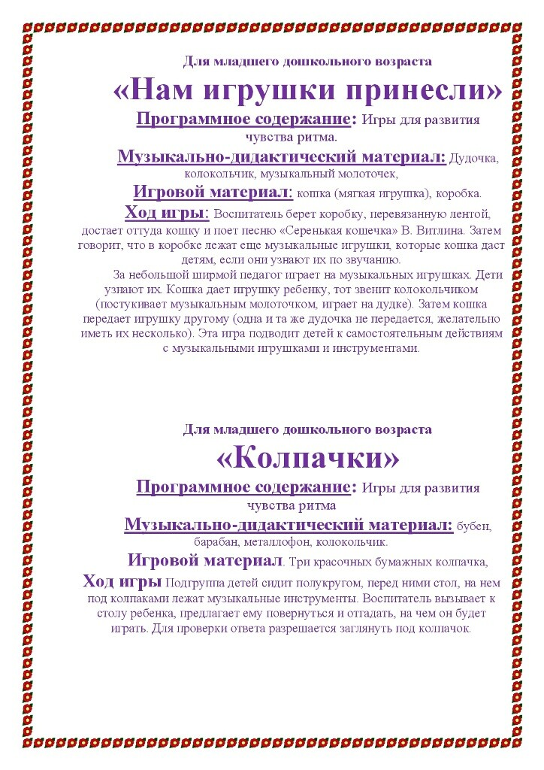](https://ok.ru/dk?cmd=PopLayerPhoto&st.layer.cmd=PopLayerPhotoOuter&st.layer.type=GROUP&st.layer.revNav=off&st.layer.limitedUi=false&st.layer.closeLayers=off&st.layer.sphotoIds=904606600917%3B904606600661%3B904606600405%3B904606600149%3B904606599893%3B904606599637%3B904606599381%3B904606599125%3B904606598869%3B904606598613%3B904606598357%3B904606598101%3B904606597845%3B904606597589%3B904606597333%3B904606597077%3B904606596821%3B904606596565%3B904606596309%3B904606596053%3B904606595797%3B904606595541%3B904606595285&st.layer.showNav=on&st.layer.photoAlbumId=52327617003733&st.layer.epm=off&st.layer.photoId=904606600149&st.layer.wasRedirect%2C=off&st.layer.opl=off&st.layer.navStartPhotoId=904606600149&st.layer.navStartAlbumId%2C=52327617003733&st.layer.sbd=off&st.cmd=altGroupForum&st.groupId=52327565361365&st._aid=GroupTopicLayer_openPhotoLayer)

[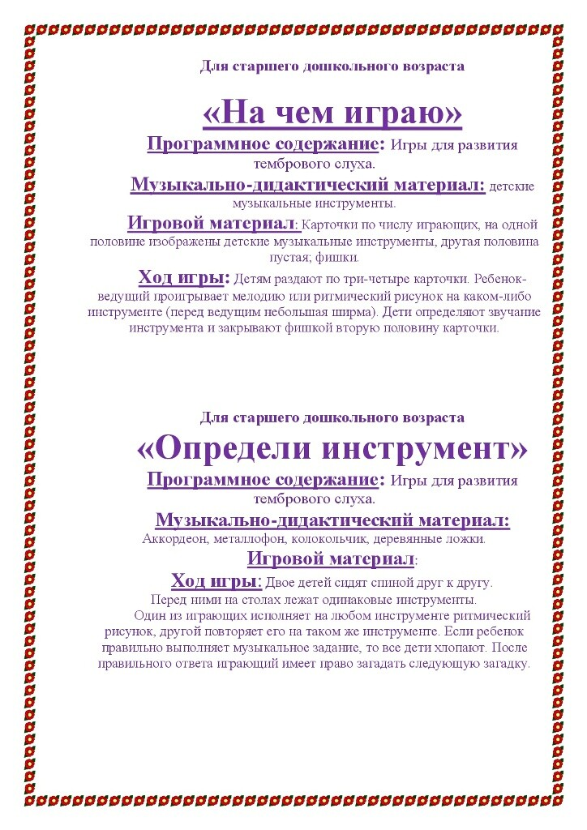](https://ok.ru/dk?cmd=PopLayerPhoto&st.layer.cmd=PopLayerPhotoOuter&st.layer.type=GROUP&st.layer.revNav=off&st.layer.limitedUi=false&st.layer.closeLayers=off&st.layer.sphotoIds=904606600917%3B904606600661%3B904606600405%3B904606600149%3B904606599893%3B904606599637%3B904606599381%3B904606599125%3B904606598869%3B904606598613%3B904606598357%3B904606598101%3B904606597845%3B904606597589%3B904606597333%3B904606597077%3B904606596821%3B904606596565%3B904606596309%3B904606596053%3B904606595797%3B904606595541%3B904606595285&st.layer.showNav=on&st.layer.photoAlbumId=52327617003733&st.layer.epm=off&st.layer.photoId=904606599381&st.layer.wasRedirect%2C=off&st.layer.opl=off&st.layer.navStartPhotoId=904606599381&st.layer.navStartAlbumId%2C=52327617003733&st.layer.sbd=off&st.cmd=altGroupForum&st.groupId=52327565361365&st._aid=GroupTopicLayer_openPhotoLayer)

[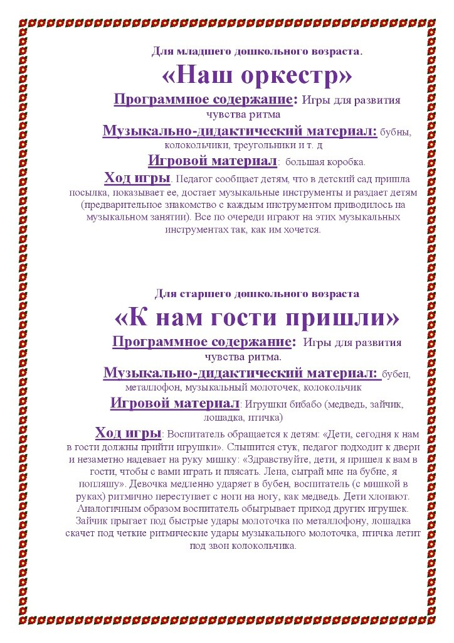](https://ok.ru/dk?cmd=PopLayerPhoto&st.layer.cmd=PopLayerPhotoOuter&st.layer.type=GROUP&st.layer.revNav=off&st.layer.limitedUi=false&st.layer.closeLayers=off&st.layer.sphotoIds=904606600917%3B904606600661%3B904606600405%3B904606600149%3B904606599893%3B904606599637%3B904606599381%3B904606599125%3B904606598869%3B904606598613%3B904606598357%3B904606598101%3B904606597845%3B904606597589%3B904606597333%3B904606597077%3B904606596821%3B904606596565%3B904606596309%3B904606596053%3B904606595797%3B904606595541%3B904606595285&st.layer.showNav=on&st.layer.photoAlbumId=52327617003733&st.layer.epm=off&st.layer.photoId=904606599893&st.layer.wasRedirect%2C=off&st.layer.opl=off&st.layer.navStartPhotoId=904606599893&st.layer.navStartAlbumId%2C=52327617003733&st.layer.sbd=off&st.cmd=altGroupForum&st.groupId=52327565361365&st._aid=GroupTopicLayer_openPhotoLayer)

[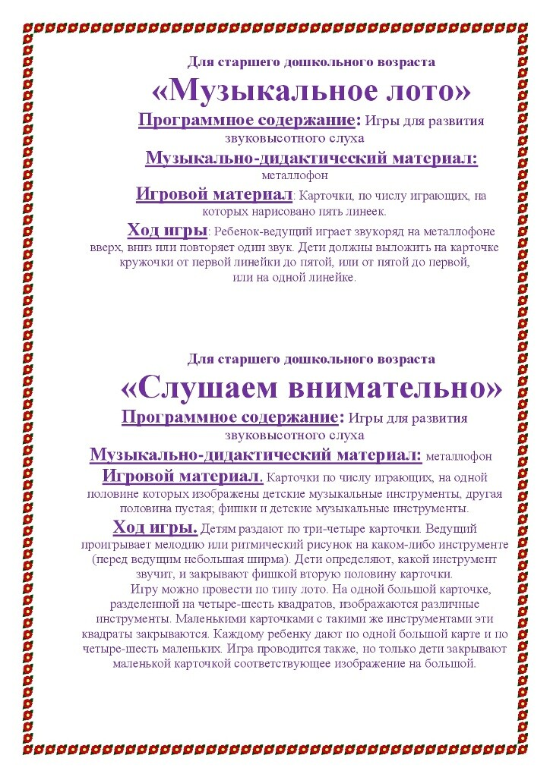](https://ok.ru/dk?cmd=PopLayerPhoto&st.layer.cmd=PopLayerPhotoOuter&st.layer.type=GROUP&st.layer.revNav=off&st.layer.limitedUi=false&st.layer.closeLayers=off&st.layer.sphotoIds=904606600917%3B904606600661%3B904606600405%3B904606600149%3B904606599893%3B904606599637%3B904606599381%3B904606599125%3B904606598869%3B904606598613%3B904606598357%3B904606598101%3B904606597845%3B904606597589%3B904606597333%3B904606597077%3B904606596821%3B904606596565%3B904606596309%3B904606596053%3B904606595797%3B904606595541%3B904606595285&st.layer.showNav=on&st.layer.photoAlbumId=52327617003733&st.layer.epm=off&st.layer.photoId=904606599125&st.layer.wasRedirect%2C=off&st.layer.opl=off&st.layer.navStartPhotoId=904606599125&st.layer.navStartAlbumId%2C=52327617003733&st.layer.sbd=off&st.cmd=altGroupForum&st.groupId=52327565361365&st._aid=GroupTopicLayer_openPhotoLayer)

[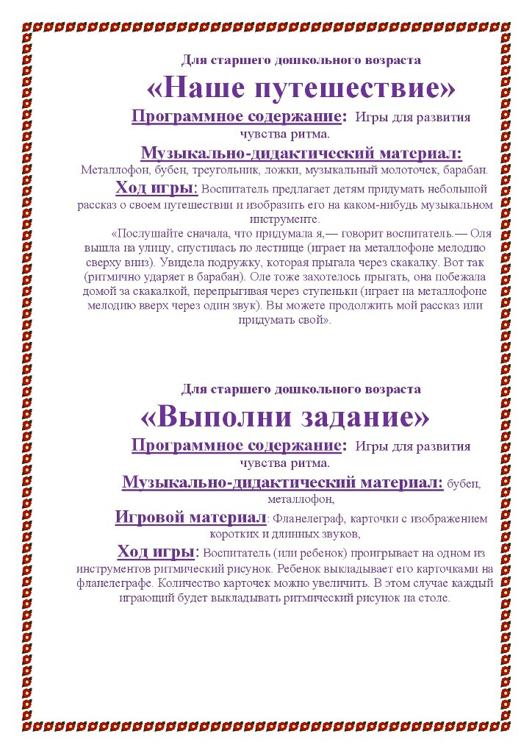](https://ok.ru/dk?cmd=PopLayerPhoto&st.layer.cmd=PopLayerPhotoOuter&st.layer.type=GROUP&st.layer.revNav=off&st.layer.limitedUi=false&st.layer.closeLayers=off&st.layer.sphotoIds=904606600917%3B904606600661%3B904606600405%3B904606600149%3B904606599893%3B904606599637%3B904606599381%3B904606599125%3B904606598869%3B904606598613%3B904606598357%3B904606598101%3B904606597845%3B904606597589%3B904606597333%3B904606597077%3B904606596821%3B904606596565%3B904606596309%3B904606596053%3B904606595797%3B904606595541%3B904606595285&st.layer.showNav=on&st.layer.photoAlbumId=52327617003733&st.layer.epm=off&st.layer.photoId=904606599637&st.layer.wasRedirect%2C=off&st.layer.opl=off&st.layer.navStartPhotoId=904606599637&st.layer.navStartAlbumId%2C=52327617003733&st.layer.sbd=off&st.cmd=altGroupForum&st.groupId=52327565361365&st._aid=GroupTopicLayer_openPhotoLayer)

[](https://ok.ru/dk?cmd=PopLayerPhoto&st.layer.cmd=PopLayerPhotoOuter&st.layer.type=GROUP&st.layer.revNav=off&st.layer.limitedUi=false&st.layer.closeLayers=off&st.layer.sphotoIds=904531135701%3B904531135445%3B904531135189%3B904531134933%3B904531134677%3B904531134421%3B904531134165%3B904531133909%3B904531133653%3B904531133397&st.layer.showNav=on&st.layer.photoAlbumId=52327617003733&st.layer.epm=off&st.layer.photoId=904531135701&st.layer.wasRedirect%2C=off&st.layer.opl=off&st.layer.navStartPhotoId=904531135701&st.layer.navStartAlbumId%2C=52327617003733&st.layer.sbd=off&st.cmd=altGroupForum&st.groupId=52327565361365&st._aid=GroupTopicLayer_openPhotoLayer)[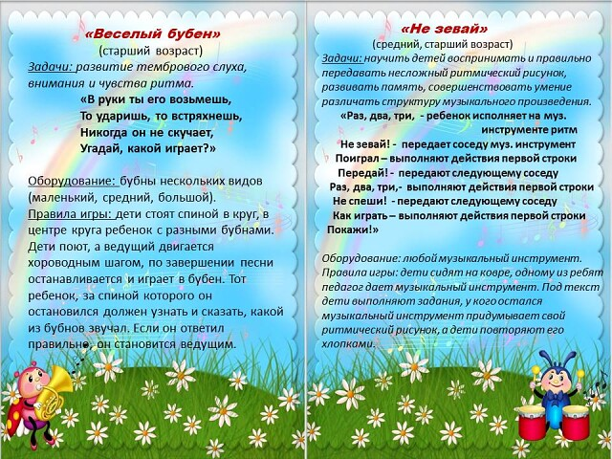](https://ok.ru/dk?cmd=PopLayerPhoto&st.layer.cmd=PopLayerPhotoOuter&st.layer.type=GROUP&st.layer.revNav=off&st.layer.limitedUi=false&st.layer.closeLayers=off&st.layer.sphotoIds=904531135701%3B904531135445%3B904531135189%3B904531134933%3B904531134677%3B904531134421%3B904531134165%3B904531133909%3B904531133653%3B904531133397&st.layer.showNav=on&st.layer.photoAlbumId=52327617003733&st.layer.epm=off&st.layer.photoId=904531135445&st.layer.wasRedirect%2C=off&st.layer.opl=off&st.layer.navStartPhotoId=904531135445&st.layer.navStartAlbumId%2C=52327617003733&st.layer.sbd=off&st.cmd=altGroupForum&st.groupId=52327565361365&st._aid=GroupTopicLayer_openPhotoLayer)

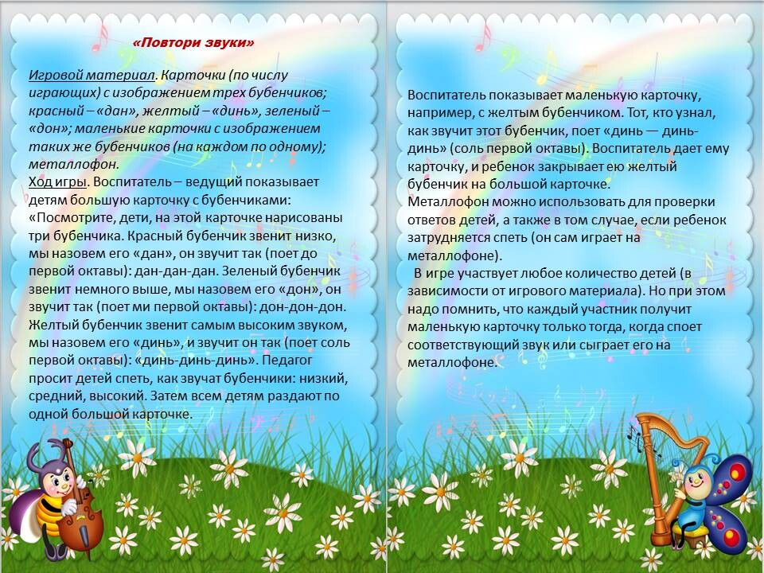

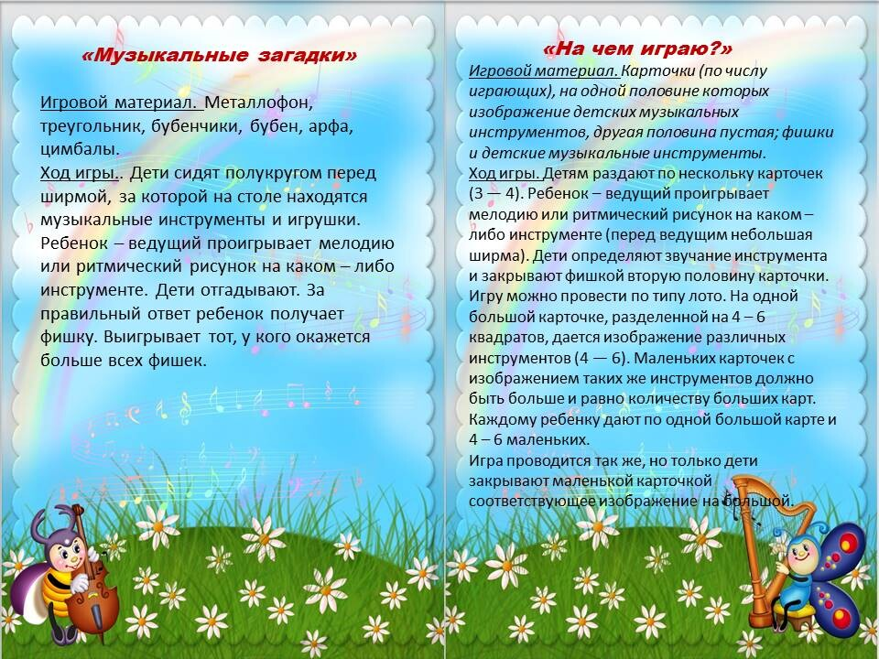

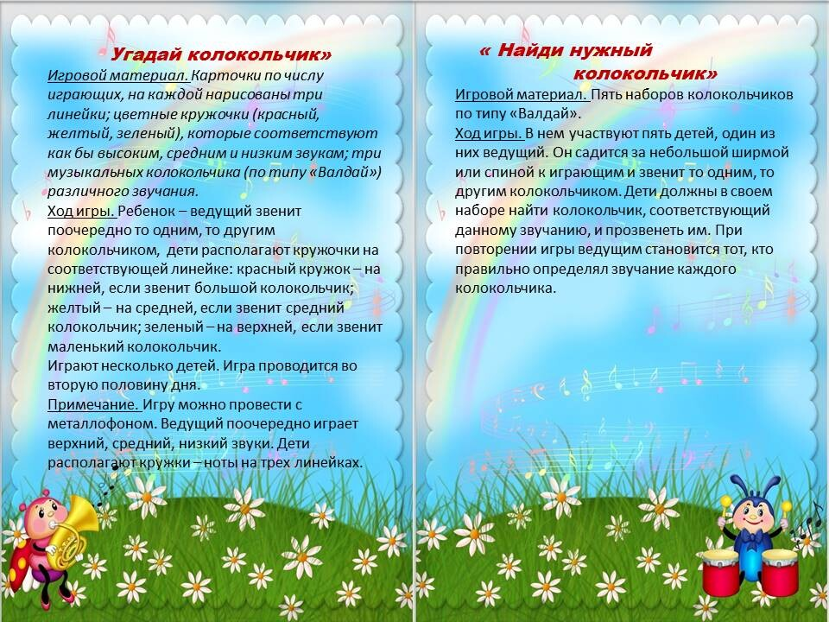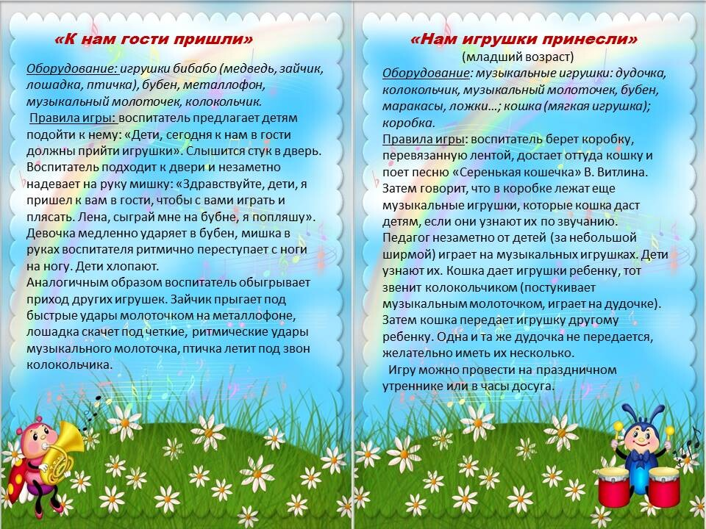

[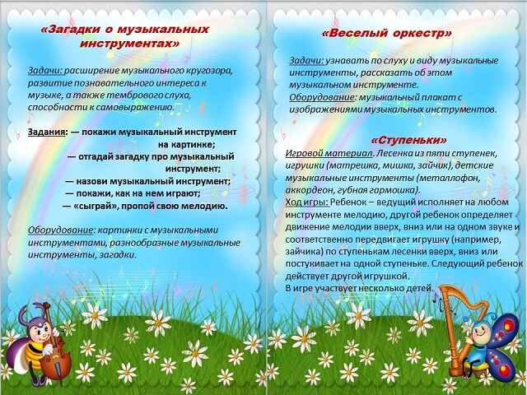](https://ok.ru/dk?cmd=PopLayerPhoto&st.layer.cmd=PopLayerPhotoOuter&st.layer.type=GROUP&st.layer.revNav=off&st.layer.limitedUi=false&st.layer.closeLayers=off&st.layer.sphotoIds=904531135701%3B904531135445%3B904531135189%3B904531134933%3B904531134677%3B904531134421%3B904531134165%3B904531133909%3B904531133653%3B904531133397&st.layer.showNav=on&st.layer.photoAlbumId=52327617003733&st.layer.epm=off&st.layer.photoId=904531135189&st.layer.wasRedirect%2C=off&st.layer.opl=off&st.layer.navStartPhotoId=904531135189&st.layer.navStartAlbumId%2C=52327617003733&st.layer.sbd=off&st.cmd=altGroupForum&st.groupId=52327565361365&st._aid=GroupTopicLayer_openPhotoLayer)

[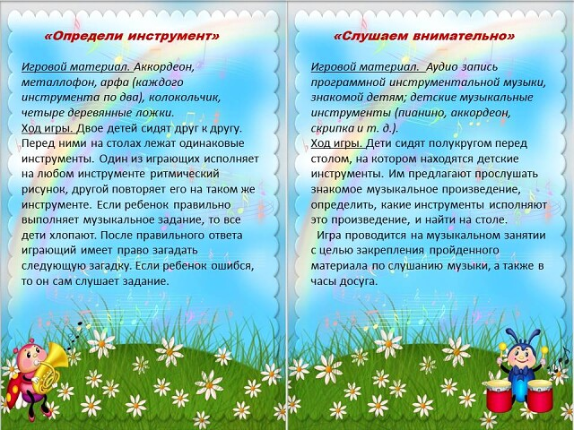](https://ok.ru/dk?cmd=PopLayerPhoto&st.layer.cmd=PopLayerPhotoOuter&st.layer.type=GROUP&st.layer.revNav=off&st.layer.limitedUi=false&st.layer.closeLayers=off&st.layer.sphotoIds=904531135701%3B904531135445%3B904531135189%3B904531134933%3B904531134677%3B904531134421%3B904531134165%3B904531133909%3B904531133653%3B904531133397&st.layer.showNav=on&st.layer.photoAlbumId=52327617003733&st.layer.epm=off&st.layer.photoId=904531134165&st.layer.wasRedirect%2C=off&st.layer.opl=off&st.layer.navStartPhotoId=904531134165&st.layer.navStartAlbumId%2C=52327617003733&st.layer.sbd=off&st.cmd=altGroupForum&st.groupId=52327565361365&st._aid=GroupTopicLayer_openPhotoLayer)

[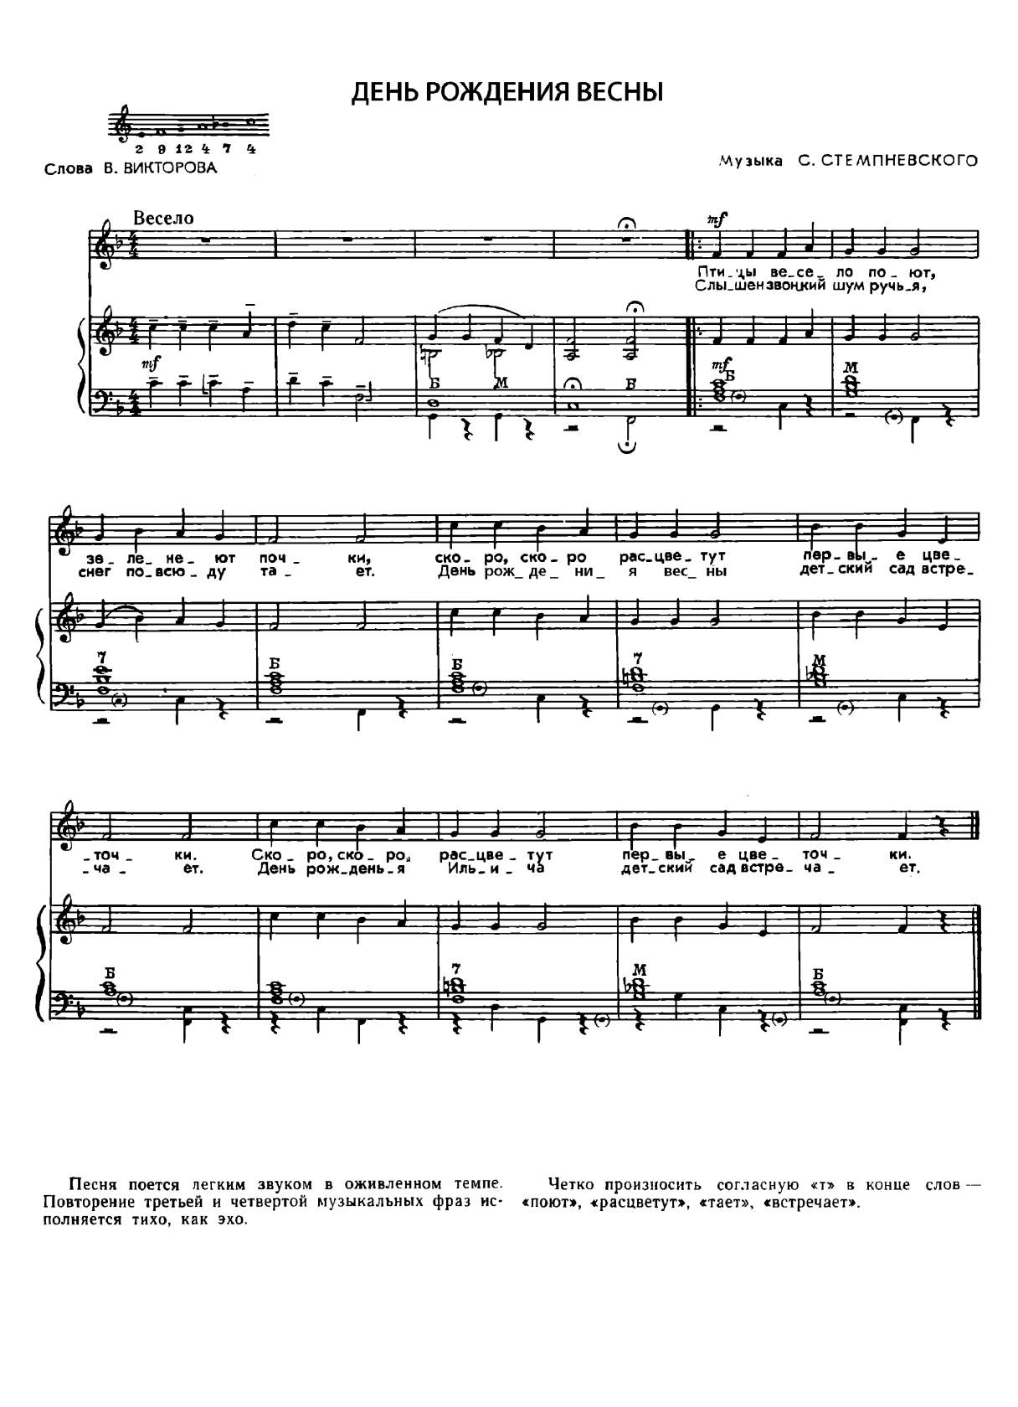](https://ok.ru/dk?cmd=PopLayerPhoto&st.layer.cmd=PopLayerPhotoOuter&st.layer.type=GROUP&st.layer.revNav=off&st.layer.limitedUi=false&st.layer.closeLayers=off&st.layer.sphotoIds=904531602133%3B904531612885%3B904531639509%3B904531639253%3B904531638997%3B904531638741%3B904531638485%3B904531637973%3B904531637717%3B904531637461%3B904531637205%3B904531636949&st.layer.showNav=on&st.layer.photoAlbumId=52327617003733&st.layer.epm=off&st.layer.photoId=904531612885&st.layer.wasRedirect%2C=off&st.layer.opl=off&st.layer.navStartPhotoId=904531612885&st.layer.navStartAlbumId%2C=52327617003733&st.layer.sbd=off&st.cmd=altGroupForum&st.groupId=52327565361365&st._aid=GroupTopicLayer_openPhotoLayer)

[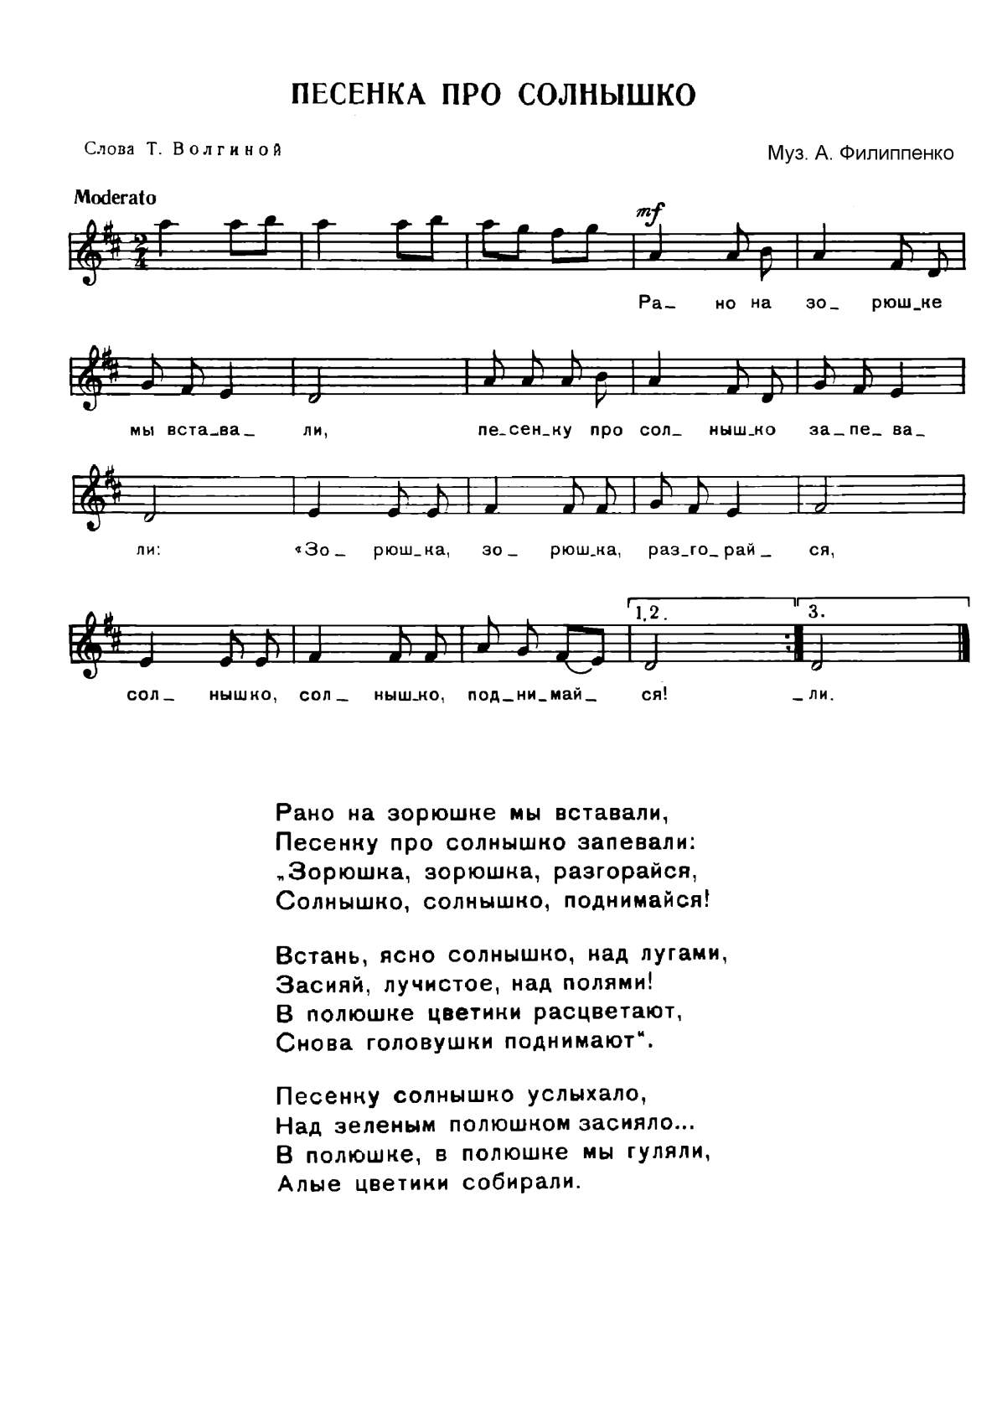](https://ok.ru/dk?cmd=PopLayerPhoto&st.layer.cmd=PopLayerPhotoOuter&st.layer.type=GROUP&st.layer.revNav=off&st.layer.limitedUi=false&st.layer.closeLayers=off&st.layer.sphotoIds=904531602133%3B904531612885%3B904531639509%3B904531639253%3B904531638997%3B904531638741%3B904531638485%3B904531637973%3B904531637717%3B904531637461%3B904531637205%3B904531636949&st.layer.showNav=on&st.layer.photoAlbumId=52327617003733&st.layer.epm=off&st.layer.photoId=904531639509&st.layer.wasRedirect%2C=off&st.layer.opl=off&st.layer.navStartPhotoId=904531639509&st.layer.navStartAlbumId%2C=52327617003733&st.layer.sbd=off&st.cmd=altGroupForum&st.groupId=52327565361365&st._aid=GroupTopicLayer_openPhotoLayer)

[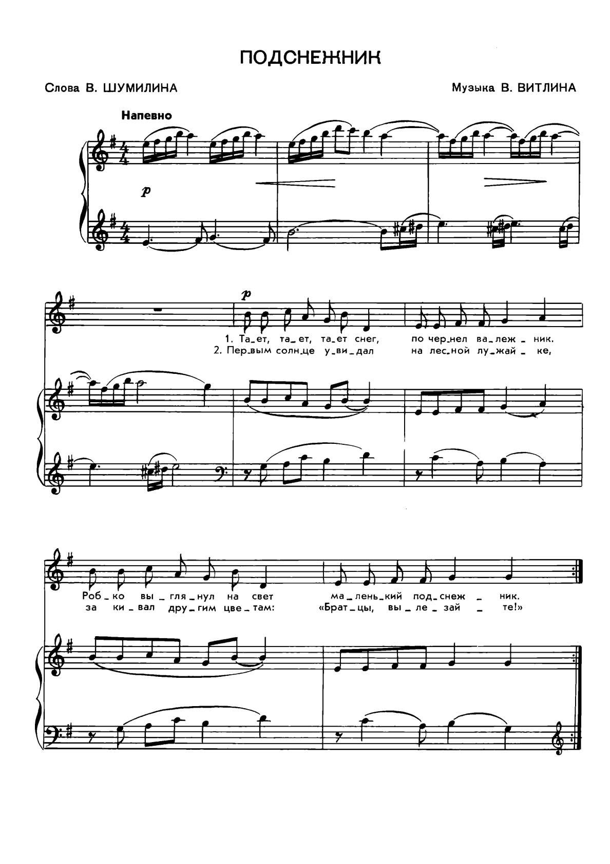](https://ok.ru/dk?cmd=PopLayerPhoto&st.layer.cmd=PopLayerPhotoOuter&st.layer.type=GROUP&st.layer.revNav=off&st.layer.limitedUi=false&st.layer.closeLayers=off&st.layer.sphotoIds=904531602133%3B904531612885%3B904531639509%3B904531639253%3B904531638997%3B904531638741%3B904531638485%3B904531637973%3B904531637717%3B904531637461%3B904531637205%3B904531636949&st.layer.showNav=on&st.layer.photoAlbumId=52327617003733&st.layer.epm=off&st.layer.photoId=904531639253&st.layer.wasRedirect%2C=off&st.layer.opl=off&st.layer.navStartPhotoId=904531639253&st.layer.navStartAlbumId%2C=52327617003733&st.layer.sbd=off&st.cmd=altGroupForum&st.groupId=52327565361365&st._aid=GroupTopicLayer_openPhotoLayer)

[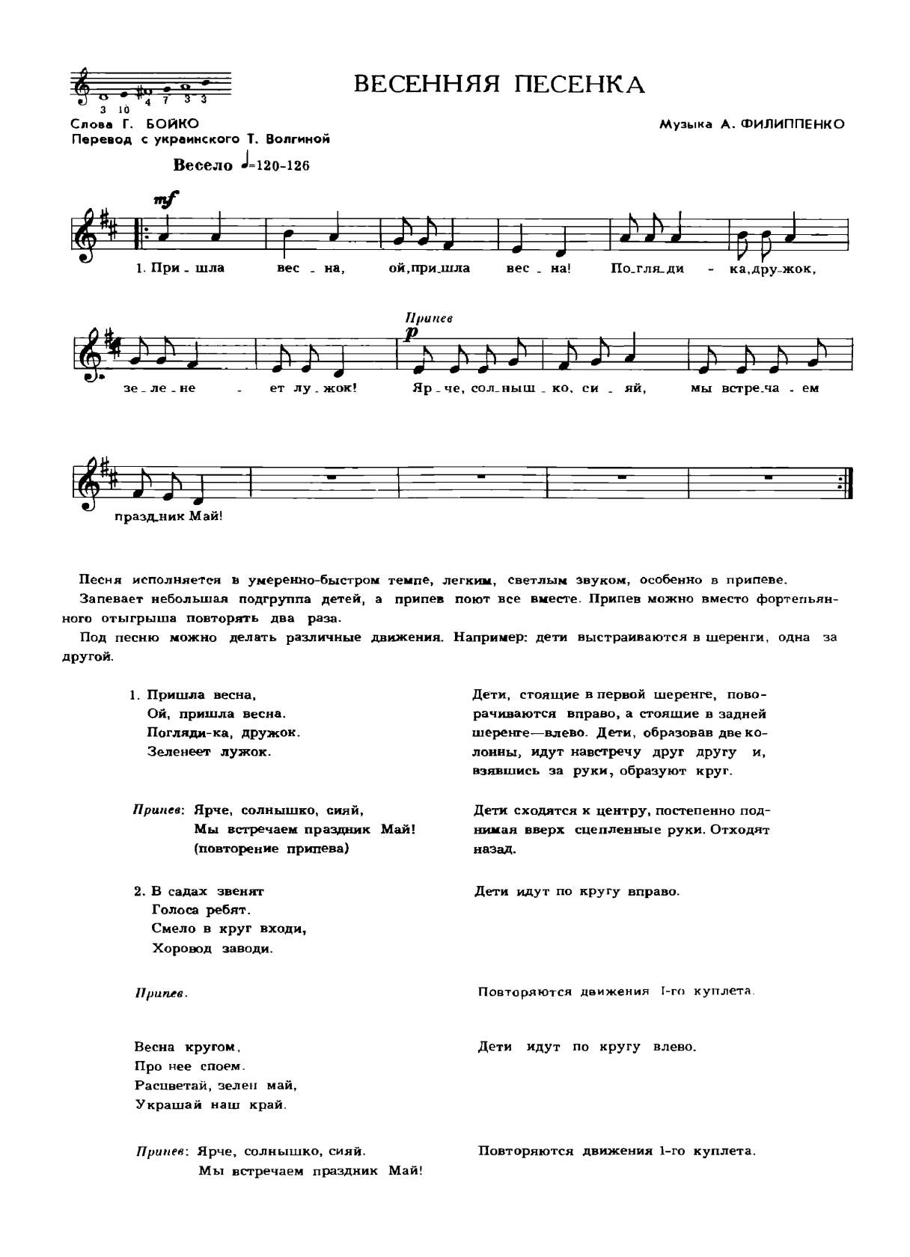](https://ok.ru/dk?cmd=PopLayerPhoto&st.layer.cmd=PopLayerPhotoOuter&st.layer.type=GROUP&st.layer.revNav=off&st.layer.limitedUi=false&st.layer.closeLayers=off&st.layer.sphotoIds=904531602133%3B904531612885%3B904531639509%3B904531639253%3B904531638997%3B904531638741%3B904531638485%3B904531637973%3B904531637717%3B904531637461%3B904531637205%3B904531636949&st.layer.showNav=on&st.layer.photoAlbumId=52327617003733&st.layer.epm=off&st.layer.photoId=904531638741&st.layer.wasRedirect%2C=off&st.layer.opl=off&st.layer.navStartPhotoId=904531638741&st.layer.navStartAlbumId%2C=52327617003733&st.layer.sbd=off&st.cmd=altGroupForum&st.groupId=52327565361365&st._aid=GroupTopicLayer_openPhotoLayer)

[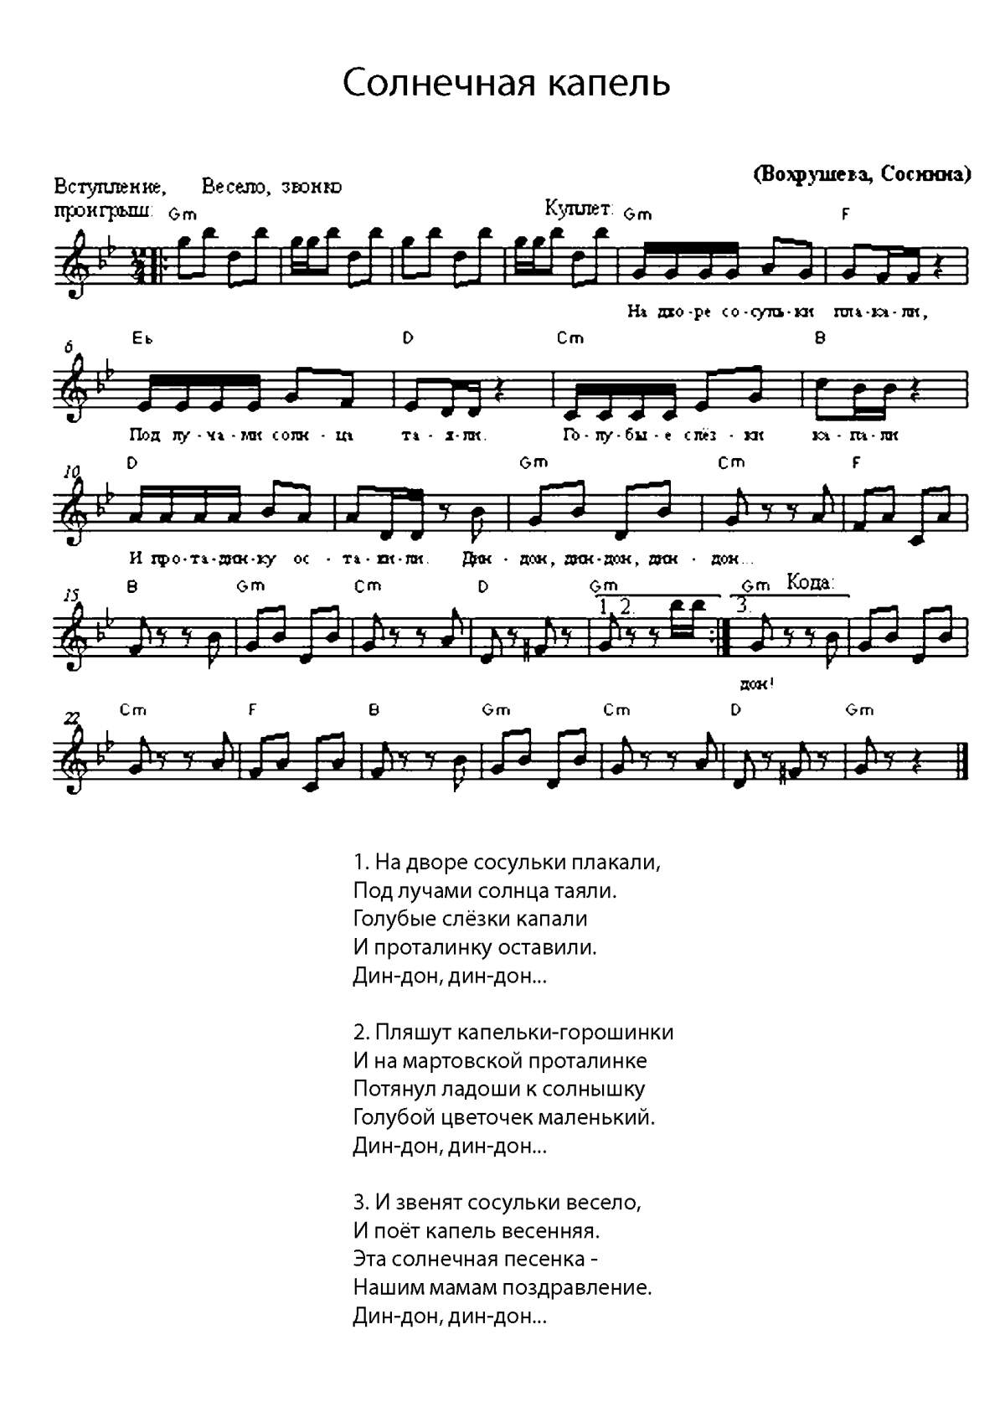](https://ok.ru/dk?cmd=PopLayerPhoto&st.layer.cmd=PopLayerPhotoOuter&st.layer.type=GROUP&st.layer.revNav=off&st.layer.limitedUi=false&st.layer.closeLayers=off&st.layer.sphotoIds=904531602133%3B904531612885%3B904531639509%3B904531639253%3B904531638997%3B904531638741%3B904531638485%3B904531637973%3B904531637717%3B904531637461%3B904531637205%3B904531636949&st.layer.showNav=on&st.layer.photoAlbumId=52327617003733&st.layer.epm=off&st.layer.photoId=904531638997&st.layer.wasRedirect%2C=off&st.layer.opl=off&st.layer.navStartPhotoId=904531638997&st.layer.navStartAlbumId%2C=52327617003733&st.layer.sbd=off&st.cmd=altGroupForum&st.groupId=52327565361365&st._aid=GroupTopicLayer_openPhotoLayer)

[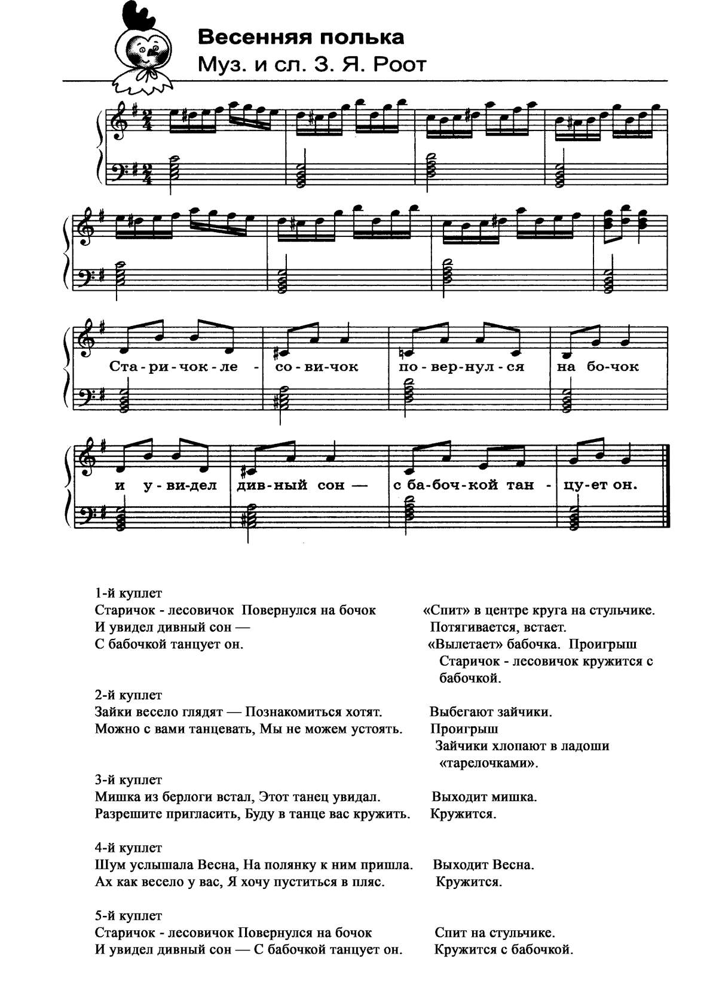](https://ok.ru/dk?cmd=PopLayerPhoto&st.layer.cmd=PopLayerPhotoOuter&st.layer.type=GROUP&st.layer.revNav=off&st.layer.limitedUi=false&st.layer.closeLayers=off&st.layer.sphotoIds=904531602133%3B904531612885%3B904531639509%3B904531639253%3B904531638997%3B904531638741%3B904531638485%3B904531637973%3B904531637717%3B904531637461%3B904531637205%3B904531636949&st.layer.showNav=on&st.layer.photoAlbumId=52327617003733&st.layer.epm=off&st.layer.photoId=904531638485&st.layer.wasRedirect%2C=off&st.layer.opl=off&st.layer.navStartPhotoId=904531638485&st.layer.navStartAlbumId%2C=52327617003733&st.layer.sbd=off&st.cmd=altGroupForum&st.groupId=52327565361365&st._aid=GroupTopicLayer_openPhotoLayer)

[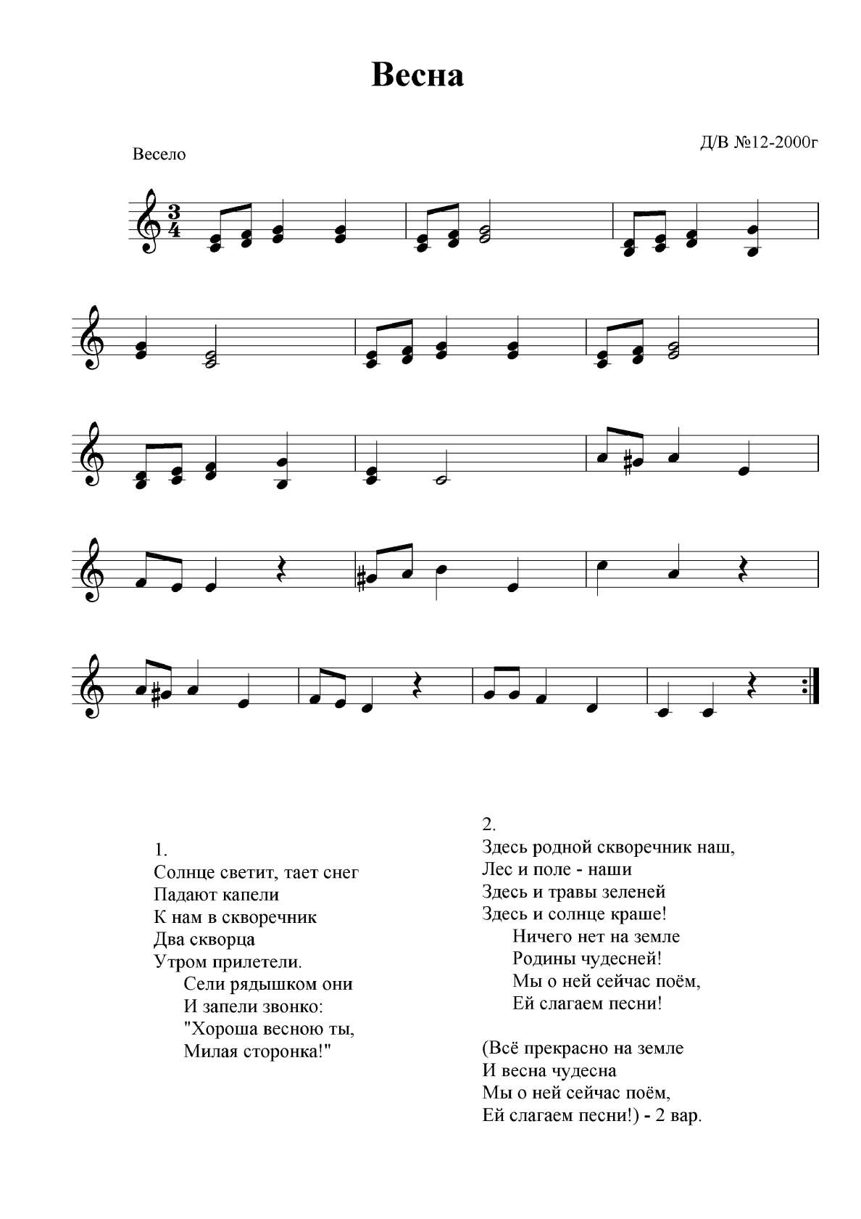](https://ok.ru/dk?cmd=PopLayerPhoto&st.layer.cmd=PopLayerPhotoOuter&st.layer.type=GROUP&st.layer.revNav=off&st.layer.limitedUi=false&st.layer.closeLayers=off&st.layer.sphotoIds=904531602133%3B904531612885%3B904531639509%3B904531639253%3B904531638997%3B904531638741%3B904531638485%3B904531637973%3B904531637717%3B904531637461%3B904531637205%3B904531636949&st.layer.showNav=on&st.layer.photoAlbumId=52327617003733&st.layer.epm=off&st.layer.photoId=904531637973&st.layer.wasRedirect%2C=off&st.layer.opl=off&st.layer.navStartPhotoId=904531637973&st.layer.navStartAlbumId%2C=52327617003733&st.layer.sbd=off&st.cmd=altGroupForum&st.groupId=52327565361365&st._aid=GroupTopicLayer_openPhotoLayer)

[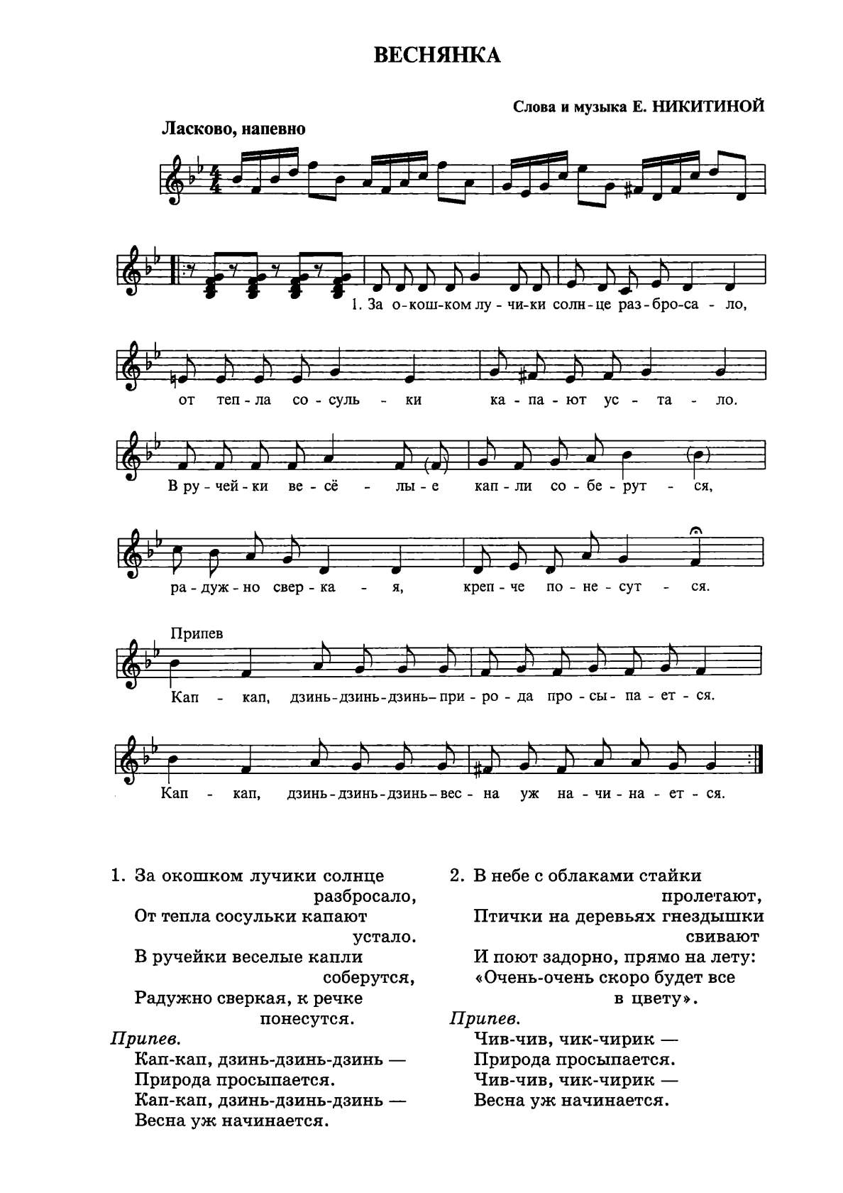](https://ok.ru/dk?cmd=PopLayerPhoto&st.layer.cmd=PopLayerPhotoOuter&st.layer.type=GROUP&st.layer.revNav=off&st.layer.limitedUi=false&st.layer.closeLayers=off&st.layer.sphotoIds=904531602133%3B904531612885%3B904531639509%3B904531639253%3B904531638997%3B904531638741%3B904531638485%3B904531637973%3B904531637717%3B904531637461%3B904531637205%3B904531636949&st.layer.showNav=on&st.layer.photoAlbumId=52327617003733&st.layer.epm=off&st.layer.photoId=904531637205&st.layer.wasRedirect%2C=off&st.layer.opl=off&st.layer.navStartPhotoId=904531637205&st.layer.navStartAlbumId%2C=52327617003733&st.layer.sbd=off&st.cmd=altGroupForum&st.groupId=52327565361365&st._aid=GroupTopicLayer_openPhotoLayer)

[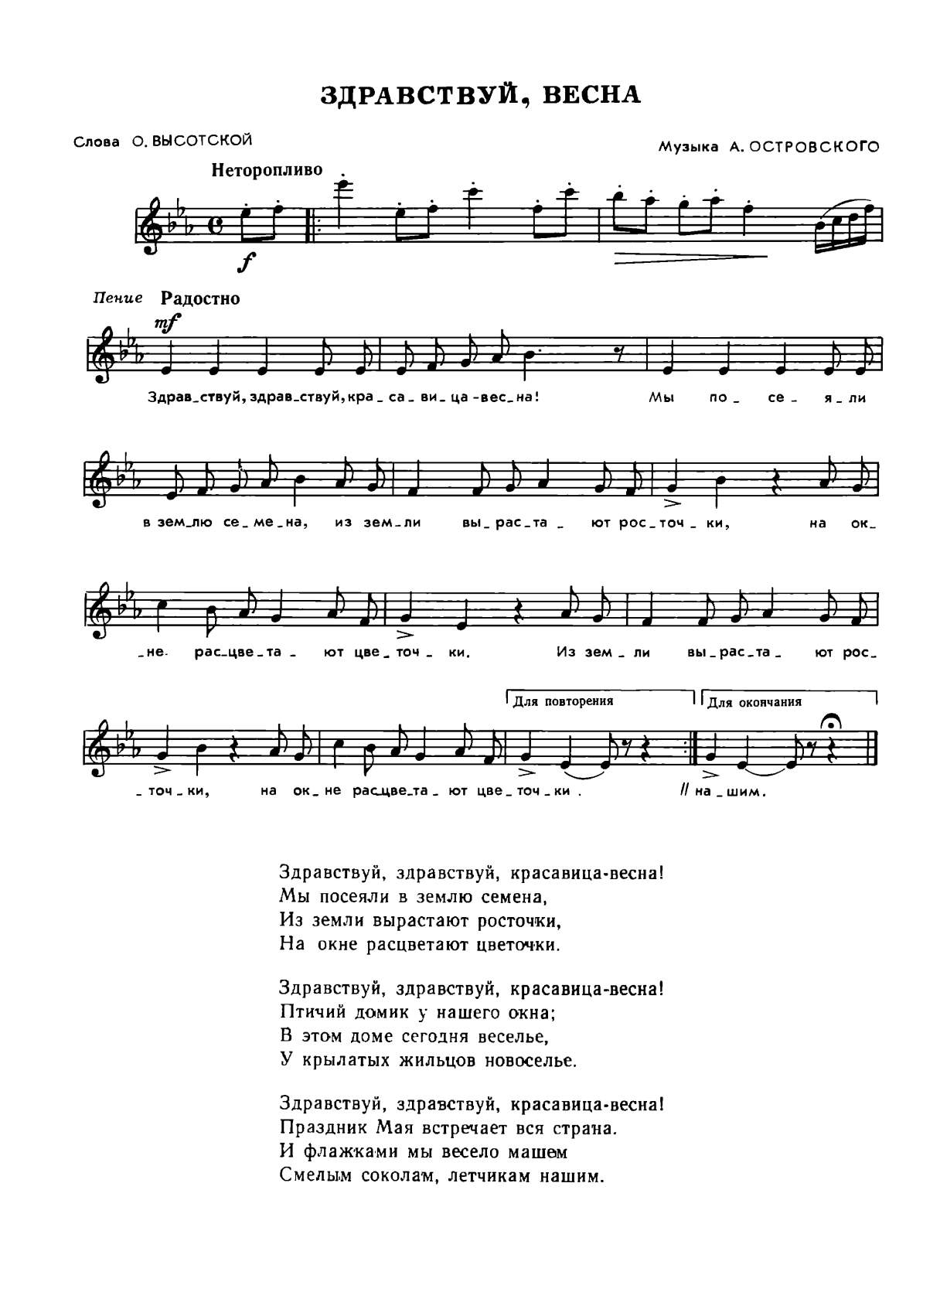](https://ok.ru/dk?cmd=PopLayerPhoto&st.layer.cmd=PopLayerPhotoOuter&st.layer.type=GROUP&st.layer.revNav=off&st.layer.limitedUi=false&st.layer.closeLayers=off&st.layer.sphotoIds=904531602133%3B904531612885%3B904531639509%3B904531639253%3B904531638997%3B904531638741%3B904531638485%3B904531637973%3B904531637717%3B904531637461%3B904531637205%3B904531636949&st.layer.showNav=on&st.layer.photoAlbumId=52327617003733&st.layer.epm=off&st.layer.photoId=904531636949&st.layer.wasRedirect%2C=off&st.layer.opl=off&st.layer.navStartPhotoId=904531636949&st.layer.navStartAlbumId%2C=52327617003733&st.layer.sbd=off&st.cmd=altGroupForum&st.groupId=52327565361365&st._aid=GroupTopicLayer_openPhotoLayer)

[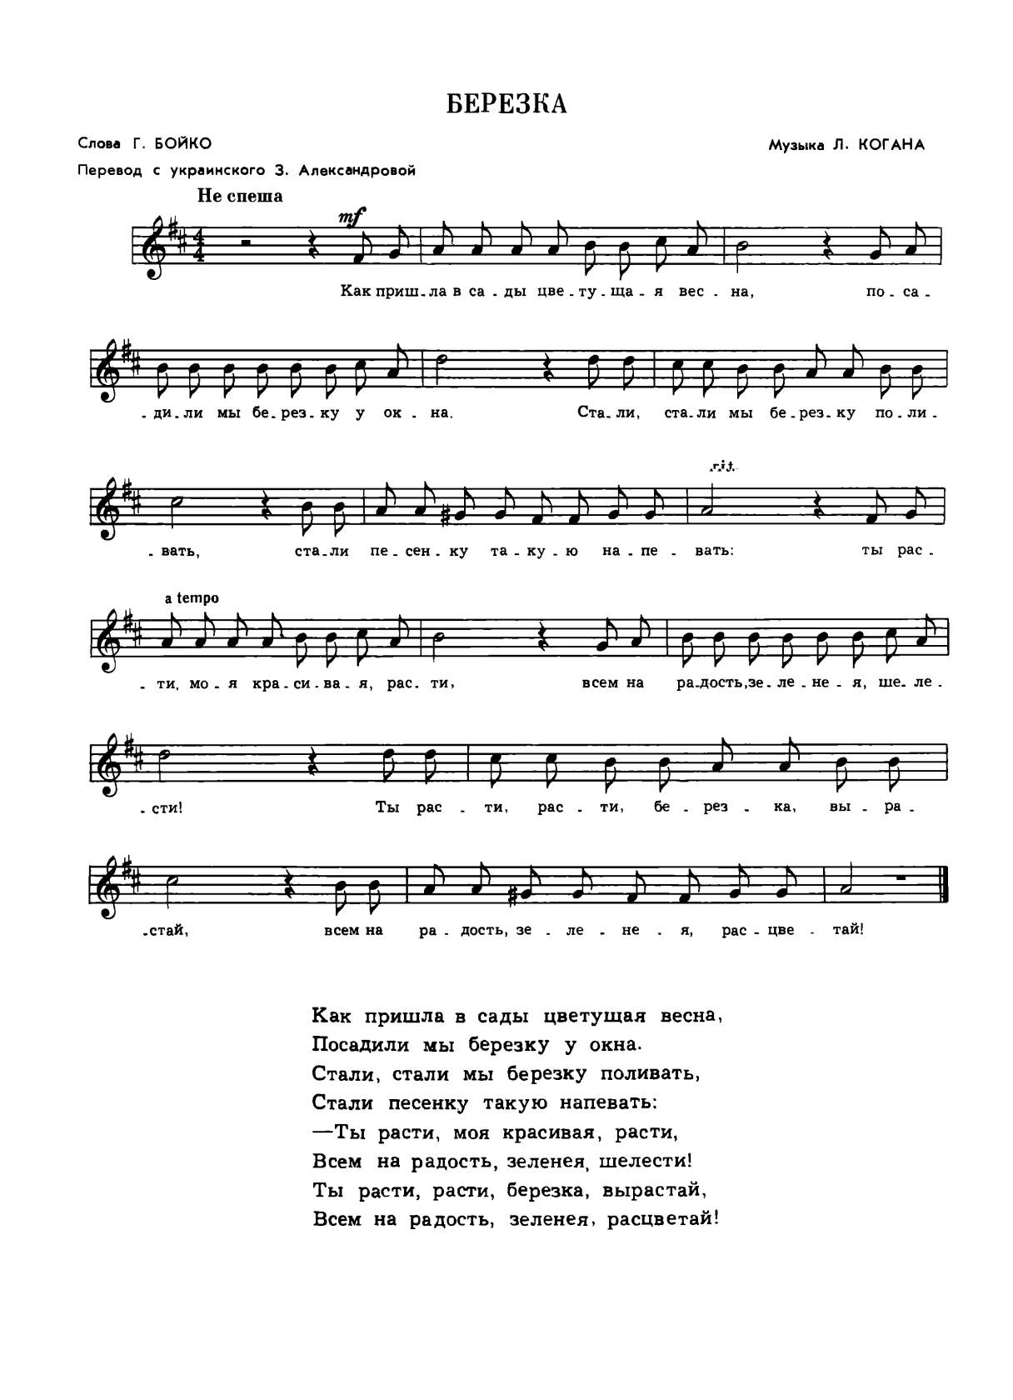](https://ok.ru/dk?cmd=PopLayerPhoto&st.layer.cmd=PopLayerPhotoOuter&st.layer.type=GROUP&st.layer.revNav=off&st.layer.limitedUi=false&st.layer.closeLayers=off&st.layer.sphotoIds=904531602133%3B904531612885%3B904531639509%3B904531639253%3B904531638997%3B904531638741%3B904531638485%3B904531637973%3B904531637717%3B904531637461%3B904531637205%3B904531636949&st.layer.showNav=on&st.layer.photoAlbumId=52327617003733&st.layer.epm=off&st.layer.photoId=904531602133&st.layer.wasRedirect%2C=off&st.layer.opl=off&st.layer.navStartPhotoId=904531602133&st.layer.navStartAlbumId%2C=52327617003733&st.layer.sbd=off&st.cmd=altGroupForum&st.groupId=52327565361365&st._aid=GroupTopicLayer_openPhotoLayer)